Tab 1

### https://docs.google.com/spreadsheets/d/1fAQ1rHf_buFcowql7ONgAj6gY01wd3u6nwM4ZAUxqhY/edit?gid=515133391#gid=515133391 Contract Processing Steps *(Implementation/Success to fill)*

DO NOT process the following customers: **AssetMark, Ronald Blue Trust, GiveClear**

For contracts that look like the following, follow the steps below to process.  
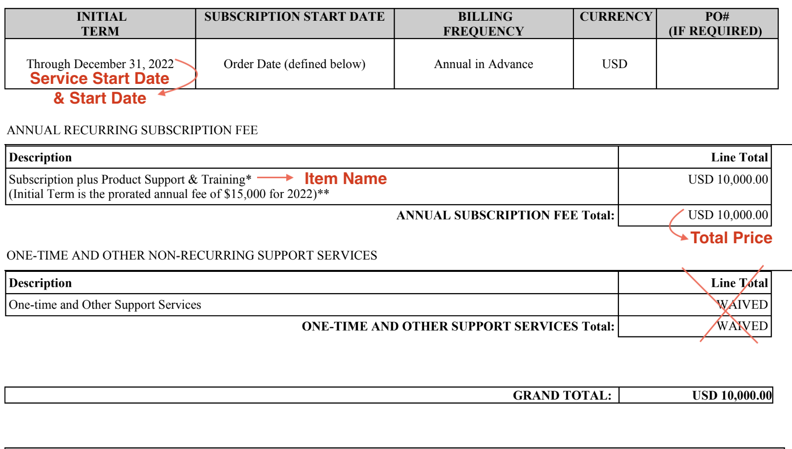

Steps to process

**Service Start Date:** Will be noted as “initial term” or under a section that includes the “order form details”

**Months of Service:** Default 36 months (3 years) if there is no date

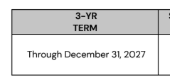

**Item Name:** Copy and paste line next to item name (see image above)

**Item Description:** none

**Integration Item:** [**TIFIN Netsuite Integration Items**](https://docs.google.com/spreadsheets/d/1fAQ1rHf_buFcowql7ONgAj6gY01wd3u6nwM4ZAUxqhY/edit?gid=515133391#gid=515133391) **please find here**

**Billing type:** Flat

**Total Price:** Found in contract, please be sure to check if it is a yearly cost or total cost for the whole contract. If it is a total cost, be sure to look for annual fee. See screenshot below

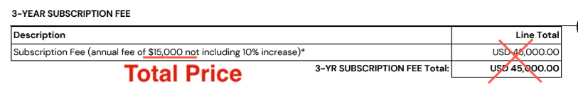

**Quantity:** 1 **Start Date:** Same as service start date

**Periods:** default to 3

**Frequency:** 1 year unless otherwise noted

**Net Terms:** Default 30

1. Anything to ignore in contracts?
   1. Anything that shows “*waived”*
2. Specifics processing things the merchant has requested that may differ by contract (e.g. always back-date invoice date to final day of the month)
3. Default Service Term
   1. Default 3 Years
4. Default Net Payment Terms
   1. Default 30
5. Default Billing Frequency
   1. If None Listed, Ops Default is Monthly
6. How do we handle taxes as a line item?
   1. If None Listed, Ops Default is every tax line item becomes a BT

### Events Processing (if necessary) *(Implementation/Success to fill)*

* Any important information on events billing

Integration Items Processing (if necessary)  
*(Implementation/Success to fill)*

* What are the instructions for assigning integration items?[TIFIN Netsuite Integration Items](https://docs.google.com/spreadsheets/d/1fAQ1rHf_buFcowql7ONgAj6gY01wd3u6nwM4ZAUxqhY/edit?gid=515133391#gid=515133391)
* Example: All Statsig integrations items should be labeled as “Sales”
* Example: All “Pinata” integration items should be labeled as “Software Subscription Bundle” unless otherwise noted by Merchant